**CRT 420 - Advanced Prototyping**

Mighty Mouse Activity

Due Jan. 29, 2018

*Summary* : The Mighty Mouse activity is designed to give students an introduction to problem-based design and refine their abilities to generate complex forms that are ergonomically sound.

*Background* : There are few technologies as ubiquitous as the computer mouse. There are a vast amount of functions, varieties, and purposes that they serve. From an everyday mouse to a hyper-specialized gaming mouse, there are a limitless variety of niche activities that can be made easier through a custom designed mouse.

**Part I - Statement of Purpose :**

Displaying one’s wealth through desk top accessory devices such as a mouse through sleek and expensive looking design.

*Activity Name*

Boujee Mouse

*Necessary Functions*

No big necessary functions besides to look boujee. It’s made to showcase one’s wealth at a desk and is made to look very modern but not necessarily made to perform any particular function. However, it is intended to be heated to stop the boss from having cold hands while he is in business meetings and shaking hands all day.

*User Characteristics*

Hates everything that doesn’t display wealth. Everything in the boss’s office is the top of the line and best of everything that exists.

**Part II - Sketches**

Generate some concept sketches that help capture the essence of the functions and characteristics defined in Part I. Include rough dimensions that seem reasonable for your application.

*Materials Needed*

Pencils, Rulers

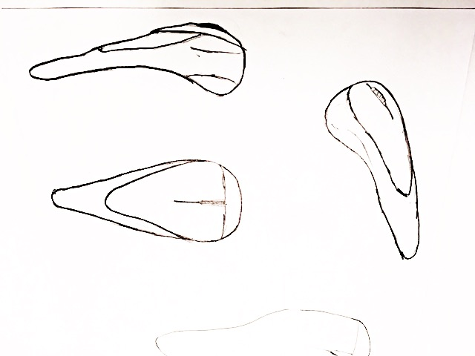

**Part III - Foam Model**

Transfer these sketches onto a block of foam. You may need to laminate several sheets of foam with spray adhesive (Super 77) to get to the right thickness for your application. Rough cut the form with the bandsaw or scroll saw. Create additional details using an X-Acto knife and sandpaper or sanding sponges. Sand to a smooth finish starting with rough sandpaper (~220 grit) and working down toward fine sandpaper (~400 grit).

*Materials Needed*

Green Foam, Super 77 Spray Adhesive, Sandpaper (220 - 400 Grit), Sanding Sponges (Medium, Fine, Extra Fine), X-Acto Knife and Blades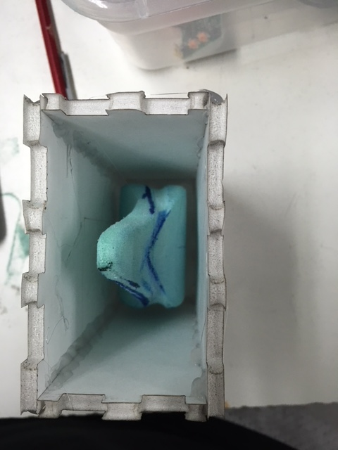 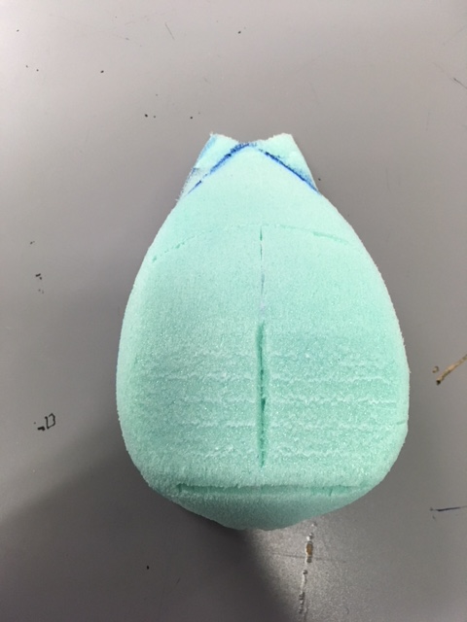 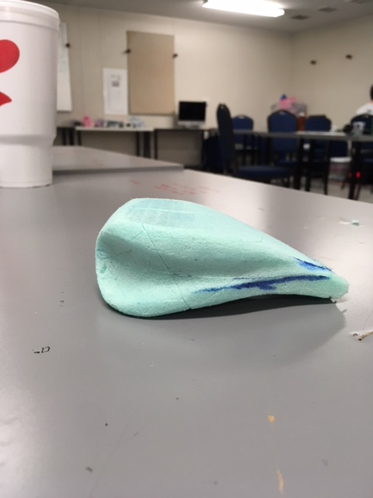

**Part IV - Silicone Mold**

*Materials Needed*

Stir bucket, ruler/caliper, foam core, laser cutter, hot glue gun, dowel rod, X-Acto knife, Mold Star 20T (Part A & B), pink colorant, digital scale, stir sticks, cutting mat

Fill your stir bucket with enough water to submerge your model. Note the change in the fluid level before and after submerging your model.

Fluid Level without Model (MA): ____20____ fl.oz.

Fluid Level with Model (MB): ___25_____ fl.oz.

Calculate the model volume (MV) (with a tolerance) using the formula below:

*VM = (MB - MA) * 0.8*

Volume of Model (VM): ___4_____ fl.oz.

*\*Multiplying the model volume by 0.8 decreases the volume to 80%. This will result in the Pour On Mold Estimator suggesting you mix up a little more material than necessary. This is good (it’s better to have too much than too little).*

Measure the overall dimensions of your model using a ruler or calipers and record your results below.

Model Width (W): ___2.75_____ inches

Model Length (L): ___5.25_____ inches

Model Height (H): __1.5______ inches

Now calculate your mold box dimensions and volume using the formulas below:

W2 = W + 0.5 L2 = L + 0.5 H2 = H + 0.5

Mold Box Width in Inches (W2) :  __3.25______ inches

Mold Box Length in Inches(L2) :  ___5.75_____ inches

Mold Box Height in Inches(H2) :  ___2_____ inches

Create a foamcore mold box using MakerCase.com to generate the laser cut plans for your mold box. Use W2, L2, and H2 as the **interior dimensions** of your box. Set the material thickness to 0.2”. Use finger joints with a maxed out tab width. Export your design and convert it in Inkscape to DXF (inches). Cut on the laser cutter and assemble the box (without the lid). Ensure all edges are sealed with hot glue. Mount your model in the box atop dowels to raise it off the bottom.

Calculate the volume of your mold box (MBV) using the formula below:

MBV = W2 * L2 * H2

Mold Box Volume (MBV) ___37.375_____ cubic inches

Use the Pour On Mold Estimator (<https://www.smooth-on.com/support/calculators/>) to find the amount of material to mix in grams. The material we are using is **Mold Star 20T**. Input the Model Volume (VM) in fluid ounces. Input the Mold Box Volume (MBV) in cubic inches. Display results as grams, calculate, and record the amount below.

Total Mix of Mold Star 20T (MIX) ____534.33____ grams

Now calculate how much of Part A and Part B of the Mold Star 20T you will need to mix:

20A = MIX * 0.5 20B = MIX * 0.5

Total Part A Mold Star 20T (20A) ___267.17_____ grams

Total Part B Mold Star 20T (20B) ___267.17_____ grams

Place all materials on top of a cutting mat (in case something spills). Place your mix bucket on a scale and zero the scale. Slowly add Part A of Mold Star 20T until the scale reads the amount of 20A. Add a small amount of pink colorant. Zero the scale and add Part B until the scale reads the total amount of 20B. Stir thoroughly for 60 seconds with a wooden stir stick until completely combined (the pink colorant) helps you see how well it’s mixed. Mold Star 20T has a pot life of 6 minutes so you will need to work briskly.

Slowly pour your mold mix into your mold box at one corner until the mold box is completely filled. Put it in a warm place where it won’t get disturbed for 30 minutes. After 30 minutes the mold will be completely cured. Peel away the foam core and using an X-Acto knife, make diagonal incisions into the mold around the edges (this will help the mold seal better). Make incrementally deeper incisions until you free your model.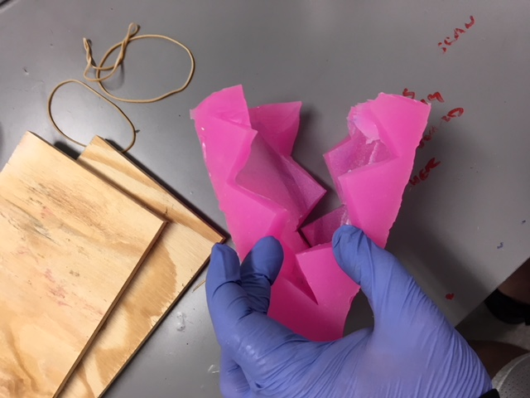 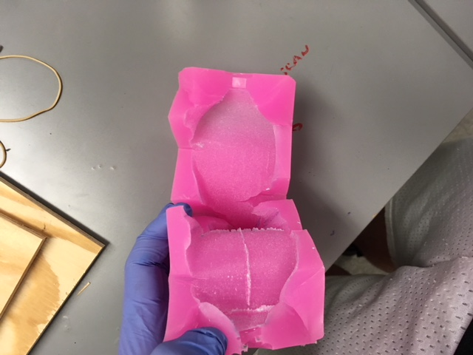

**Part V - Plastic Cast**

*Materials Needed*

Packing tape, wood scrap, Smooth Cast 300 (Part A & B), plastic cup, stir stick, cutting mat, digital scale, rotational casting machine, bungee cord, X-Acto knife, sandpaper, sanding blocks, acrylic paint.

Calculate how much casting material you will need using the formula below. This will create a shell that is ~25% of the total volume of the model:

SV = VM * 0.66

Shell Volume (SV) of Model: ____2.64____ fl.oz.

Use the Casting Estimator (<https://www.smooth-on.com/support/calculators/>) to find how must casting material to mix. Select Smooth Cast 300 for the material and enter SV in the casting volume (remember to select fl.oz. as your unit of measurement). Display results as grams and record below:

Total Mix of Smooth Cast 300 (TIX) ____93.03____ grams

Now calculate how much of each Part A and B you will need using the following formulas:

300A = TIX * 0.53 300B = TIX * 0.47

Total Part A Smooth Cast 300 (300A) ___49.3_____ grams

Total Part B Mold Star 20T (300B) ____43.72____ grams

Tape the two halves of your mold together with packing tape, making sure to leave one pour hole open. Be sure not to deform your mold by taping it too tightly. Find (or cut) two sheets of plywood that are roughly the size of your mold.

Place a plastic cup on the scale and zero the scale. Add Smooth Cast Part A until the scale reads the amount recorded in 300A. Then zero the scale and add Smooth Cast Part B until it reads the amount recorded in 300B. Mix with a stir stick for 30 seconds until well combined. The pot life is 3 minutes so you must work quickly. Pour the liquid into the open pour hole and seal the hole with packing tape. Place the mold between the two pieces of plywood and wrap a few rubber bands to hold them in place. Attach the mold to the rotational caster using the bungee cord and rotate consistently for 10 minutes. After 10 minutes, remove the mold from the caster and let it sit for an additional 5 minutes. Remove the rubber bands, plywood, and packing tape. Then remove the cast part.

Cut away the excess plastic from the pour holes and any flashing around the edges left from the seams of the mold. Sand and smooth the part and paint to a final finish.

